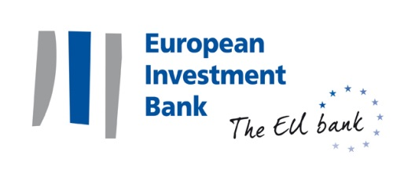
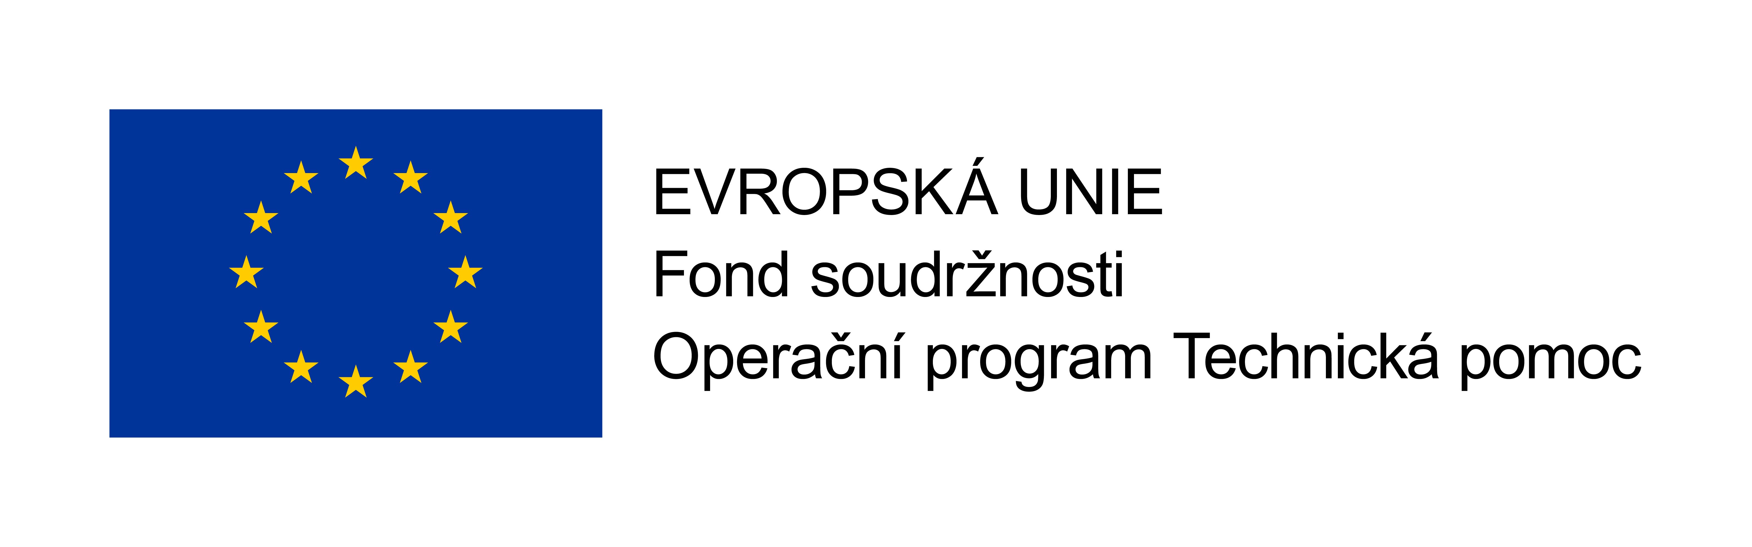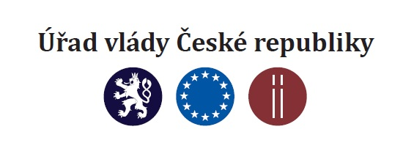

Seminar “EIB Advisory Services – Opportunities for External Consultants“

Date: Tuesday, 6.6.2016, 9:30 – 11:30
Venue: Lichtenstein Palace, U Sovovych mlynu 506/4, 118 00, Prague 1

Programme:
09:00 - 09:30 Registration and welcome coffee

09:30 - 09:35 Opening by Hana Nylander Kaloudová, Head of the EIB Group Office in the Czech Republic

09:35 – 09:45 Welcome address by Vazil Hudak, Vice President of the EIB Group

09:45 - 10:45 Presentation “EIB Advisory Services – opportunities for external consultants” by Simona Bovha, Head of Consultant Procurement and Contract Management Division, EIB Luxembourg
- Geographical and sectoral coverage of EIB advisory services (ERI Economic Resilience Initiative)
- EIB procurement rules
- How to prepare a successful bid

10:45 - 11:15 Question and Answer session

11:15 Light refreshment

